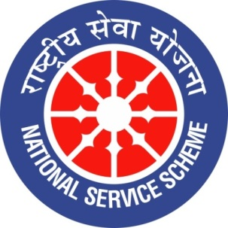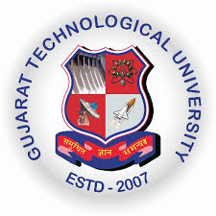
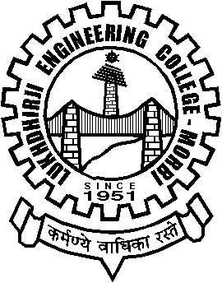
GUJARAT TECHNOLOGY UNIVERSITY
NATIONAL SERVICE SCHEME
Lukhdhirji Engineering College-Morbi
A Report on Awareness program on “Swachchhata Sarvekshan App” on 26/11/2021 of L.E.College-Morbi

NSS Unit Name/College Name: L.E.College-Morbi
Event NAME: Awareness Program on “Swachchhata Sarvekshan App”
Event Date, Time and Location: 26/11/2021,12:30 pm, Seminar hall , L.E.College
Brief Description of the Event:
Awareness Program on “Swachchhata Sarvekshan App” organized on 26/11/2021 by LEC-Morbi .Mrs. Punita Joshi- IEC consultant , DRDA-Morbi was speaker. She explained how to download app and how to operate. She explained 100 persons can give feedback from one no. She requested to give feedback. Faculties and students promised to participate in this feedback program.
Major Outcomes of Event:
- Participants came to know about Swachchhata sarvekshan app.
- Participants understand importance of Swachchhata sarvekshan.
- Participants downloaded app decided to participate and will encourage others for participation..

Photographs of the Event:
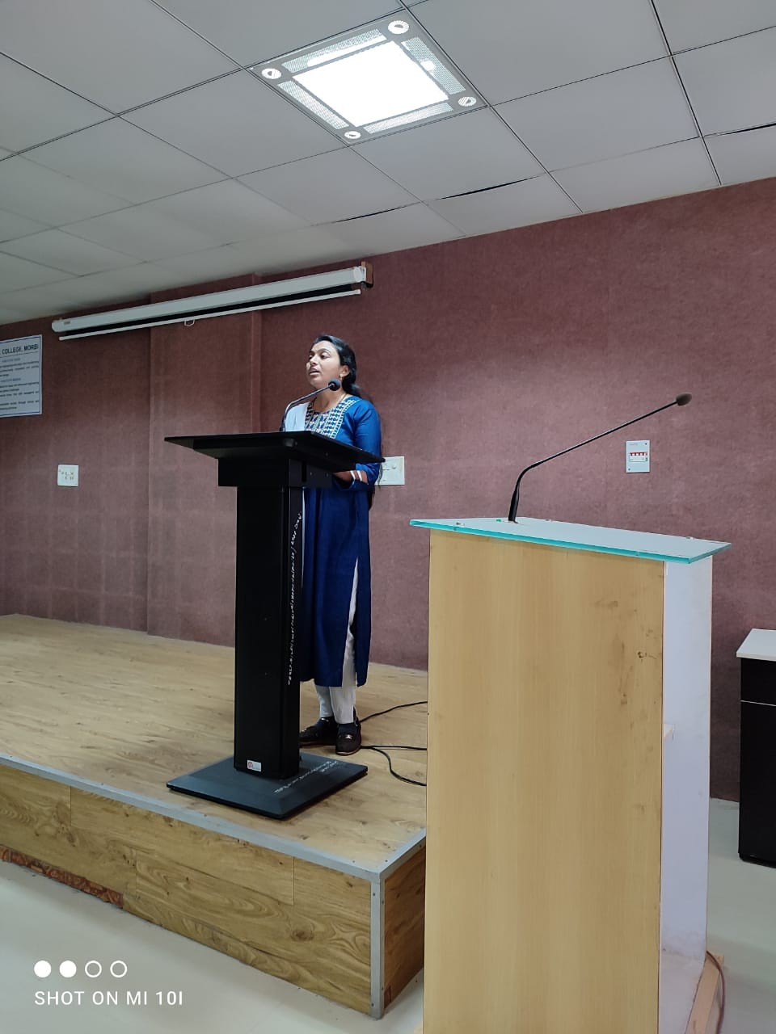

Speaker of event addressing participants
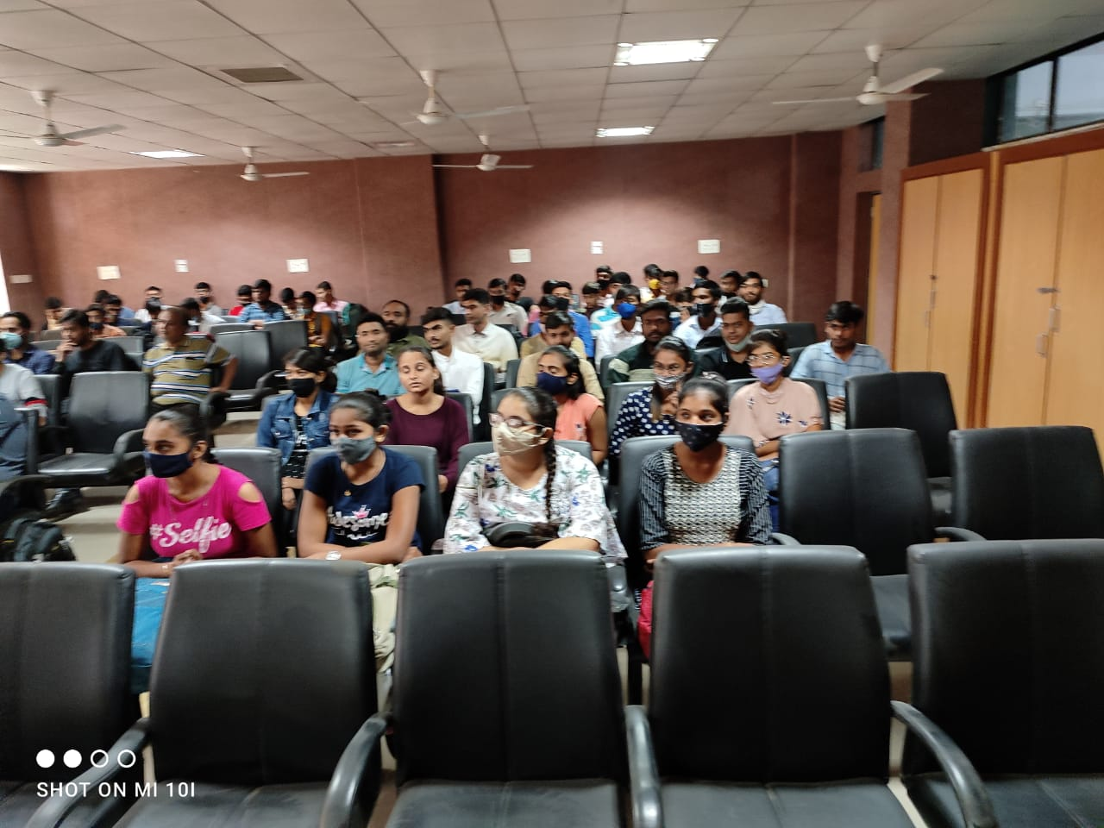
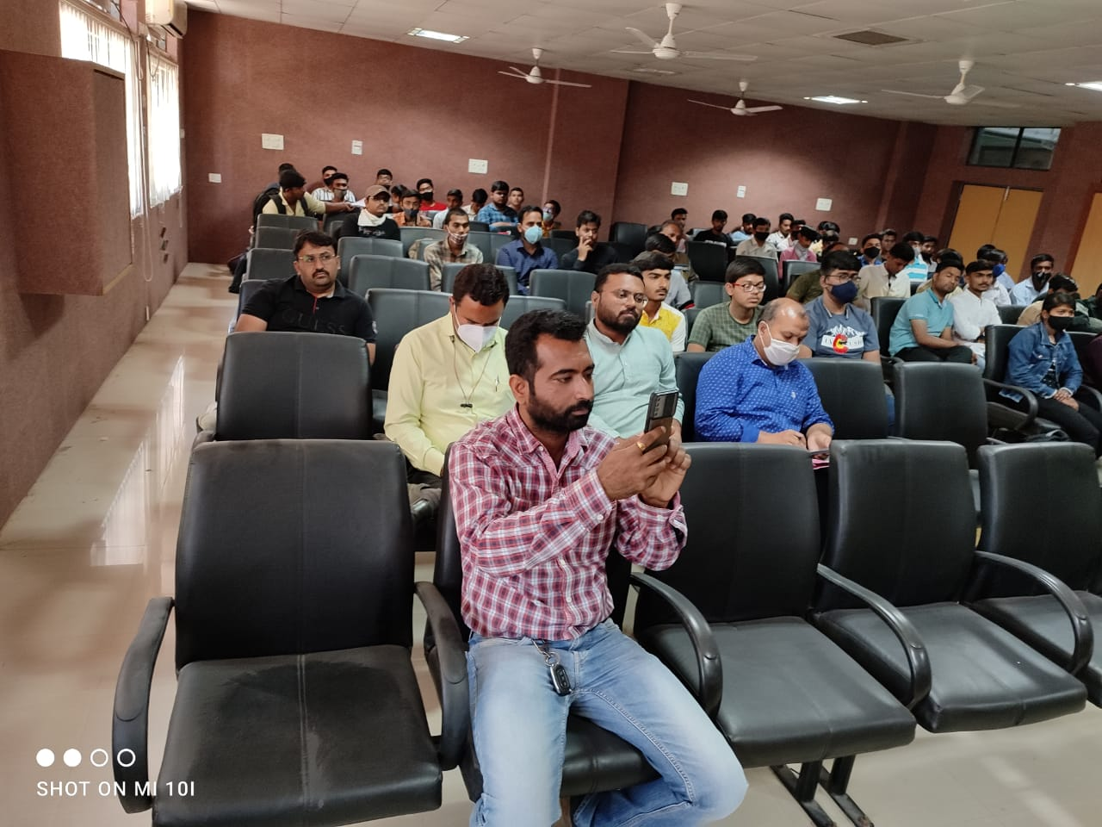

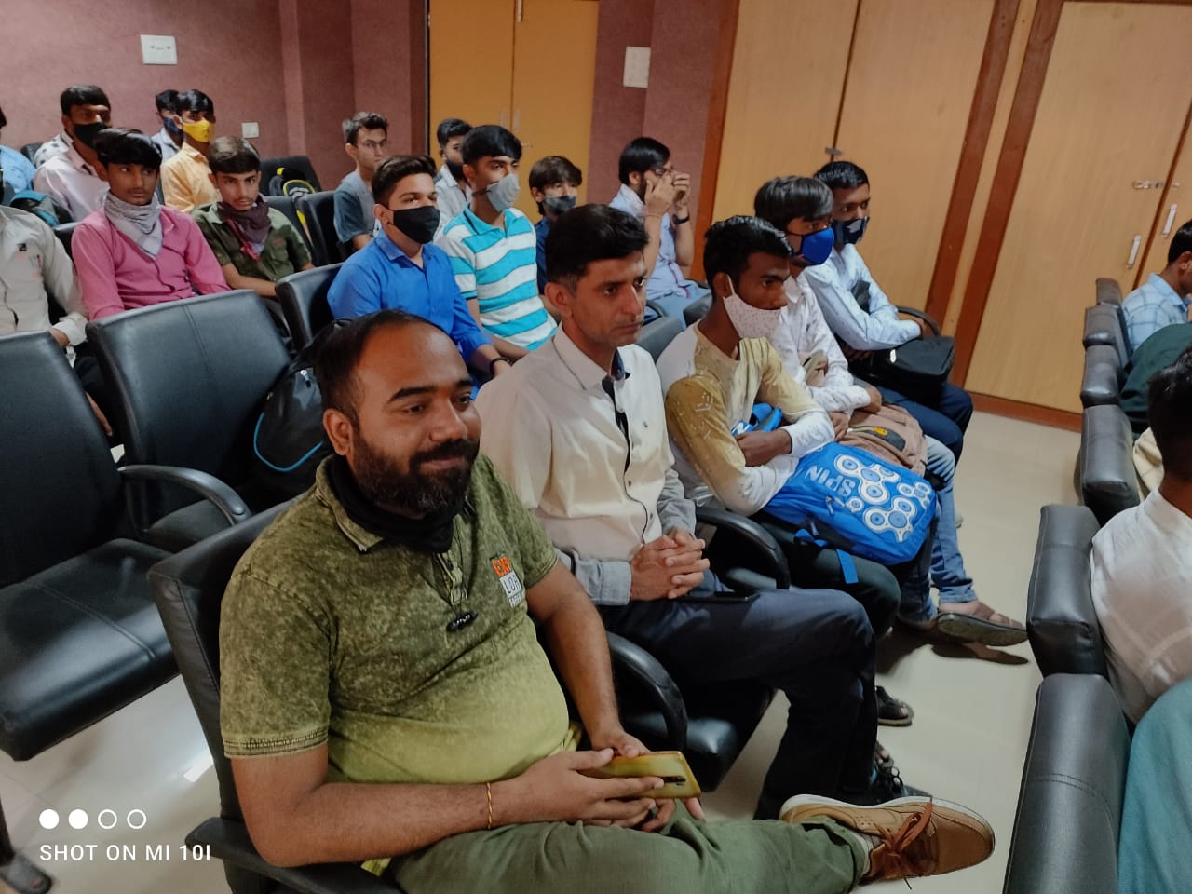

Faculty and Student participants

